Пример с тремя колонками. col-new-3 это пример класс которому мы будем задавать индивидуальные стили, и относительно, которых будеут происходить медиа-запросы.

<div class="row-2-col">

<div class="col-new-2 row-2-col__col"></div>

<div class="col-new-2 row-2-col__col"></div>

</div>

@margin:15px;

/*2 колонки*/

.row-2-col{

display: flex;

flex-wrap: wrap;

margin-left: -@margin;

margin-right:-@margin;

}

.row-2-col__col {

position: relative;

width: calc(100%/2 - @margin*2);

margin-left: @margin;

margin-right: @margin;

}

@media screen and (max-width: 930px) {

.col-new-2 {

width: calc(100%/1 - 30px);

}

}

///////////////////////////////////////////////////////////

/*3 колонки*/

.row-3-col{

display: flex;

flex-wrap: wrap;

margin-left: -@margin;

margin-right:-@margin;

}

.row-3-col__col {

position: relative;

width: calc(100%/3 - @margin*2);

margin-left: @margin;

margin-right: @margin;

}

@media screen and (max-width: 930px) {

.col-new-3 {

width: calc(100%/2 - 30px);

}

}

/////////////////////////////////////////////////////////////////

/*4 колонки*/

.row-4-col{

display: flex;

flex-wrap: wrap;

margin-left: -@margin;

margin-right:-@margin;

}

.row-4-col__col {

position: relative;

width: calc(100%/4 - @margin*2);

margin-left: @margin;

margin-right: @margin;

}

@media screen and (max-width: 930px) {

.col-new-4 {

width: calc(100%/2 - 30px);

}

}

@media screen and (max-width: 800px) {

.col-new-4 {

width: calc(100%/1 - 30px);

}

}

///////////////////////////////////////////////////////////

/*5 колонок*/

.row-5-col{

display: flex;

flex-wrap: wrap;

margin-left: -@margin;

margin-right:-@margin;

}

.row-5-col__col {

position: relative;

width: calc(100%/5 - @margin*2);

margin-left: @margin;

margin-right: @margin;

}

@media screen and (max-width: 930px) {

.col-new-5 {

width: calc(100%/4 - 30px);

}

}

@media screen and (max-width: 800px) {

.col-new-5 {

width: calc(100%/3 - 30px);

}

}

@media screen and (max-width: 750px) {

.col-new-5 {

width: calc(100%/2 - 30px);

}

}

@media screen and (max-width: 700px) {

.col-new-5 {

width: calc(100%/1 - 30px);

}

}

/////////////////////////////////////////////////////////

/*6 колонки*/

.row-6-col{

display: flex;

flex-wrap: wrap;

margin-left: -@margin;

margin-right:-@margin;

}

.row-6-col__col {

position: relative;

width: calc(100%/6 - @margin*2);

margin-left: @margin;

margin-right: @margin;

}

@media screen and (max-width: 930px) {

.col-new-6 {

width: calc(100%/3 - 30px);

}

}

@media screen and (max-width: 800px) {

.col-new-6 {

width: calc(100%/2 - 30px);

}

}

@media screen and (max-width: 760px) {

.col-new-6 {

width: calc(100%/1 - 30px);

}

}

@media screen and (max-width: 700px) {

.col-new-6 {

width: calc(100%/1 - 30px);

}

}

**Построение сетки в сетке**

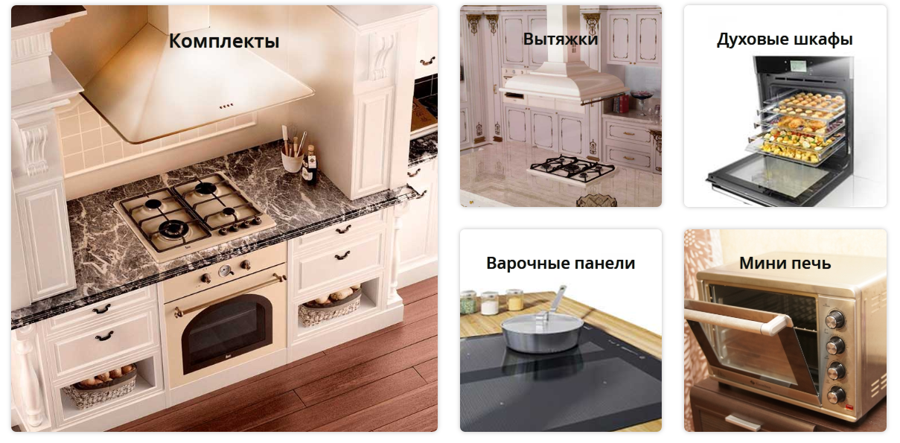

**В колонке 2 колонки**

<**div class="mn-category row-2-col"**>  
  
 <**div class="mn-category__item row-2-col__col"**></**div**>  
  
 <**div class="mn-category__item row-2-col__col row-2-col"**>  
  
 <**div class="mn-category__item row-2-col__col-m-2"**></**div**>  
  
 <**div class="mn-category__item row-2-col__col-m-2"**></**div**>  
  
 <**div class="mn-category__item row-2-col__col-m-2"**></**div**>

<**div class="mn-category__item row-2-col__col-m-2"**></**div**>  
  
 </**div**>

</**div**>

**@margin2**:15**px**;  
.**mn-section-category** .**row-2-col**{  
 **display**: **flex**;  
 *//align-items: flex-start;* **flex-wrap**: **wrap**;  
 **margin-left**: -**@margin2**;  
 **margin-right**:-**@margin2**;  
}  
  
.**mn-section-category** .**row-2-col__col** {  
 **position**: **relative**;  
 **width**: **calc**(100%/2 - **@margin2**\*2);  
 **margin-left**: **@margin2**;  
 **margin-right**: **@margin2**;  
}  
  
.**mn-section-category** .**row-2-col__col-m-2** {  
 **position**: **relative**;  
 **width**: **calc**(100%/2 - **@margin2**);

/*Так как отступ у ячеек должен быть только с одной стороны*/  
 **&**:**nth-child**(**even**){  
 **margin-left**: **@margin2**;  
 }  
 **&**:**nth-child**(**odd**){  
 **margin-right**: **@margin2**;  
 }  
}

**Обычные стили**

.**mn-section-category** .**row-2-col** {  
 **display**: **flex**;  
 **flex-wrap**: **wrap**;  
 **margin-left**: -15**px**;  
 **margin-right**: -15**px**;  
}  
.**mn-section-category** .**row-2-col__col** {  
 **position**: **relative**;  
 **width**: **calc**(100%/2 - 15**px**\*2);  
 **margin-left**: 15**px**;  
 **margin-right**: 15**px**;  
}  
.**mn-section-category** .**row-2-col__col-m** {  
 **position**: **relative**;  
 **width**: **calc**(100%/2 - 15**px**);  
}  
.**mn-section-category** .**row-2-col__col-m**:**nth-child**(**even**) {  
 **margin-left**: 15**px**;  
}  
.**mn-section-category** .**row-2-col__col-m**:**nth-child**(**odd**) {  
 **margin-right**: 15**px**;  
}

**В колонке 3 колонки**

.**row-2-col__col-m-3** {  
 **position**: **relative**;  
 **width**: **calc**((100% - **@margin2**\*4)/3);  
 **margin-bottom**: 30**px**;  
}  
.**row-2-col__col-m-3**:**nth-child**(3**n**+2) {  
 **margin-left**: **@margin2**\*2;  
}  
.**row-2-col__col-m-3**:**nth-child**(3**n**+2) {  
 **margin-right**: **@margin2**\*2;  
}

**Обычные стили**

.**row-2-col__col-m-3** {  
 **position**: **relative**;  
 **width**: **calc**((100% - 60**px**)/3);  
 **margin-bottom**: 30**px**;  
}  
.**row-2-col__col-m-3**:**nth-child**(3**n**+2) {  
 **margin-left**: 30**px**;  
}  
.**row-2-col__col-m-3**:**nth-child**(3**n**+2) {  
 **margin-right**: 30**px**;  
}

**В колонке 4 колонки**

.**row-2-col__col-m-4** {  
 **position**: **relative**;  
 **width**: **calc**((100% - **@margin**\*6)/4);  
 **margin-bottom**: 30**px**;  
}  
  
.**row-2-col__col-m-4**:**nth-child**(4**n**+2) {  
 **margin-left**: **@margin*2**;  
 **margin-right**: **@margin**;  
}  
.**row-2-col__col-m-4**:**nth-child**(4**n**+3) {  
 **margin-right**: **@margin*2**;  
 **margin-left**: **@margin**;  
}

**Обычные стили**

.**row-2-col__col-m-4** {  
 **position**: **relative**;  
 **width**: **calc**((100% - 90**px**)/4);  
 **margin-bottom**: 30**px**;  
}  
  
.**row-2-col__col-m-4**:**nth-child**(4**n**+2) {  
 **margin-left**: 30**px**;  
 **margin-right**: 15**px**;  
}  
.**row-2-col__col-m-4**:**nth-child**(4**n**+3) {  
 **margin-right**: 30**px**;  
 **margin-left**: 15**px**;  
}